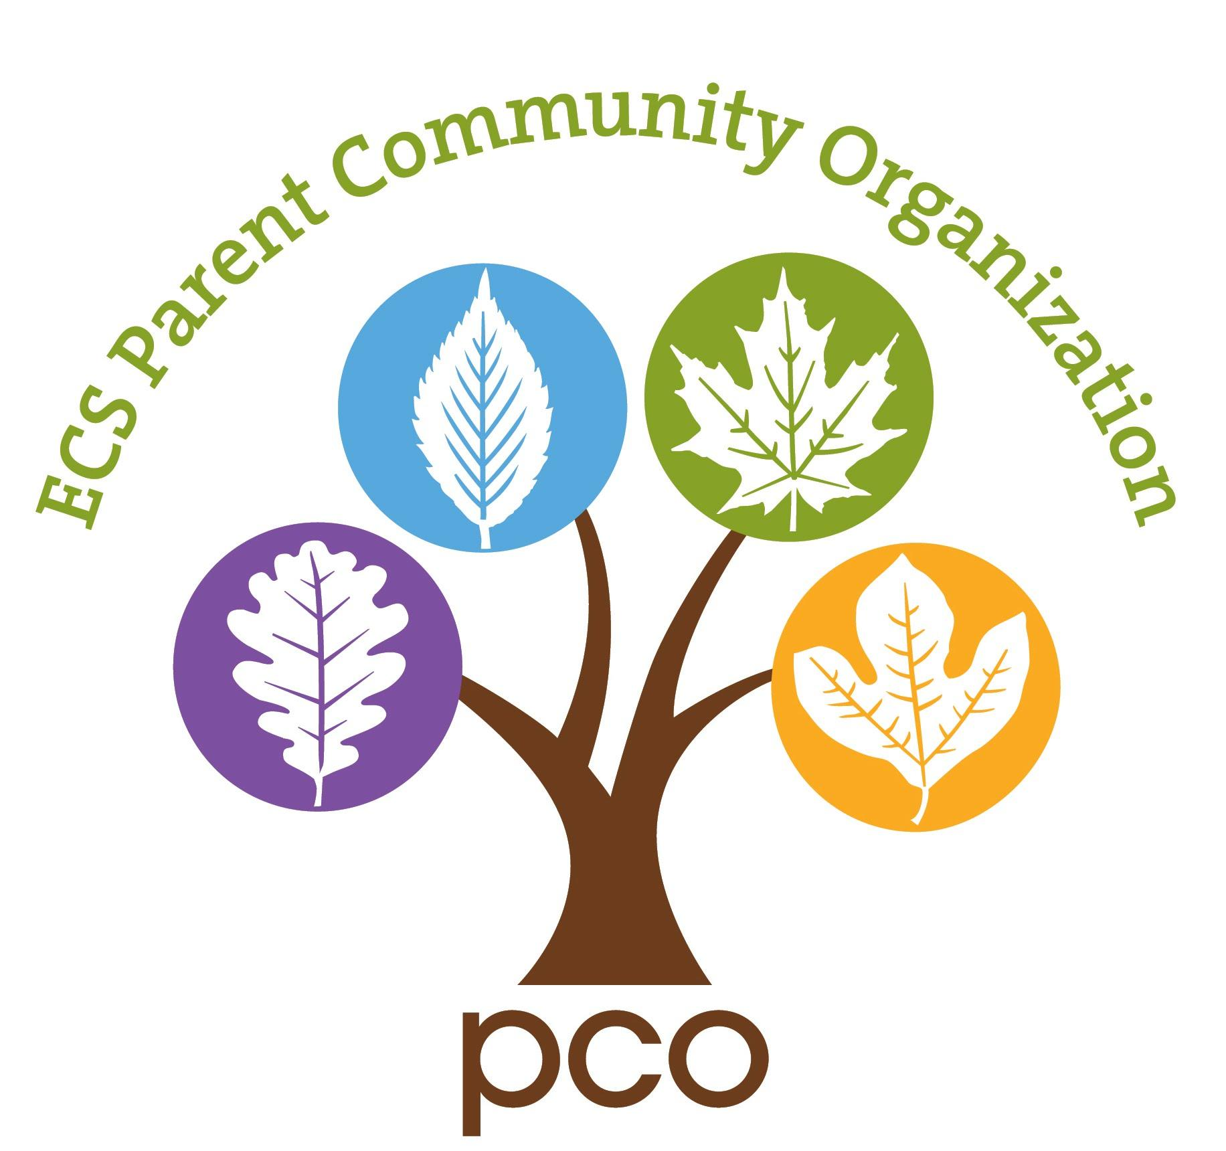
Environmental Charter School PCO
Blooming Bash Fundraiser
March 21, 2020 at the Union Project

2020 Auction/ Donation Agreement
Deadline for contributions is March 7, 2020

Sponsor or Company Name (as you would like it to appear):
________________________________________________________________________

Contact name: _____________________________Phone: __________________
Street Address: _____________________________________________________
City, State and Zip code: ______________________________________________
Email address:______________________________________________________

Sponsorship Amount or Description (if donating an item or service - please be as detailed as possible):

Value: $_________ Expiration date: _________________
Restrictions, if any (black out dates, new members only…): _____________________________________________________________________

Check One:
__ Check (payable to ECS PCO), item or gift certificate is enclosed with this letter
__ I will send/ deliver check or items to the Environmental Charter School PCO at 829 Milton St. Pittsburgh, PA 15218 Attn: Beth Jones, Blooming Bash
__ Please contact me to arrange pick up
__ Please make a gift certificate for me using the information provided above

Sponsor’s/ donor’s signature and date: ______________________________________

Please mail the top portion to this form to:
Environmental Charter School PCO at 829 Milton St. Pittsburgh, PA 15218
Attn: Beth Jones, Blooming Bash
Questions? Contact Beth Jones, event co-chair, at bloomingbash@ecspco.org or 724-650-4949

Please retain this information for your records
Donation: ___________________________ Value: _________ Date: _______________

Thank you for your donation to the ECS PCO Blooming Bash! Tax ID # 26-2437942
Donations are tax deductible in accordance with applicable law.

